Supplemental Figures
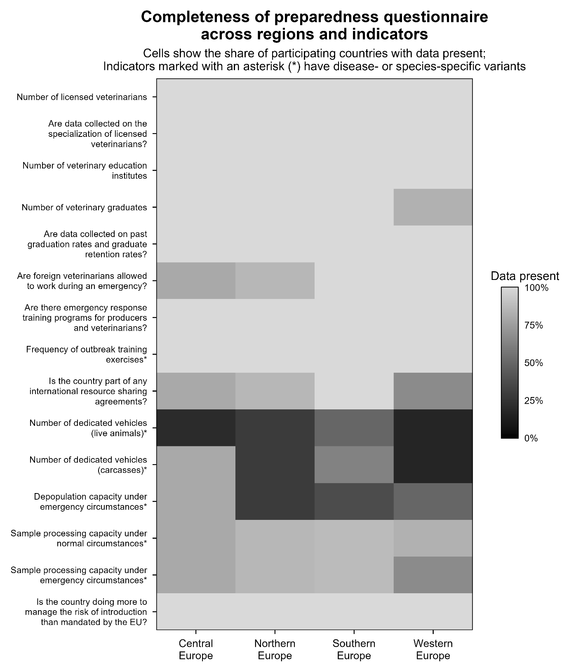
Figure S1. Completeness of preparedness questionnaire data by region and indicator. Shading shows the proportion of countries in each study region (columns) with a non-missing value for each of the 15 preparedness indicators (Table 2; rows), from black (0%) to light gray (100%). EU = European Union.
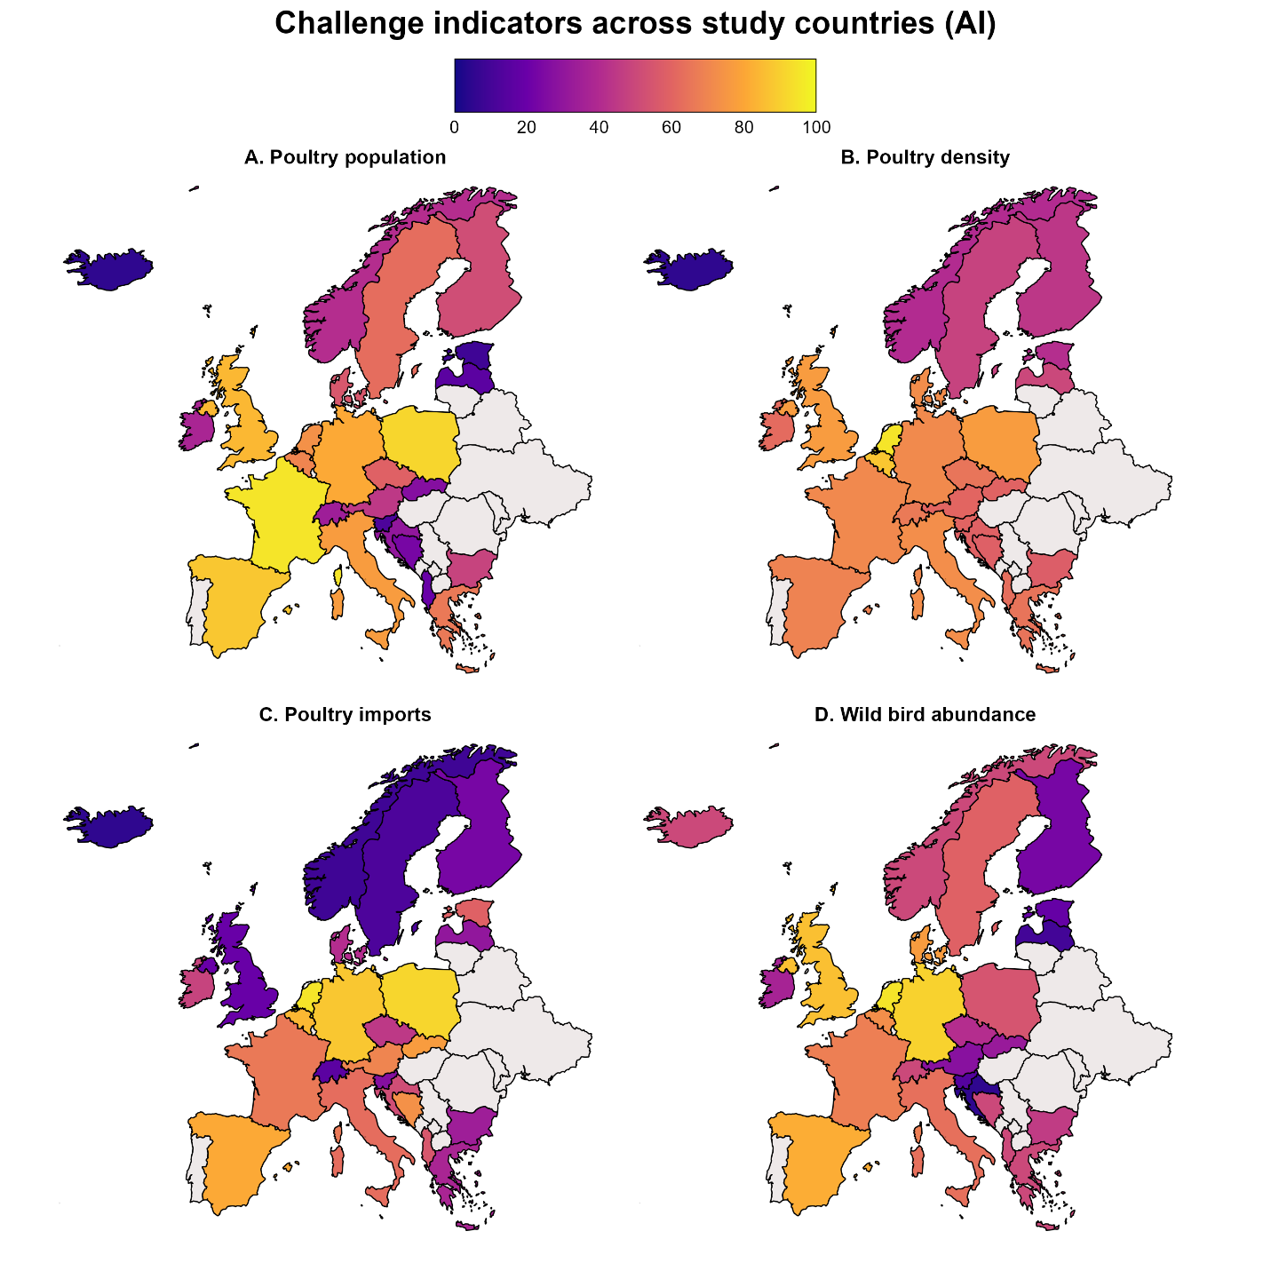
Figure S2. Avian influenza (AI) Challenge indicators: (A) poultry population, (B) poultry density, (C) poultry imports, and (D) wild bird abundance. Panels A, C, and D show rank-scaled values, and panel B shows log-transformed, min-max scaled density. All panels share a common 0-100 color scale. The resulting Challenge Index is shown in Figure 3A. Countries shown in gray were not included in the study. Map lines delineate study areas and do not necessarily depict accepted national boundaries.

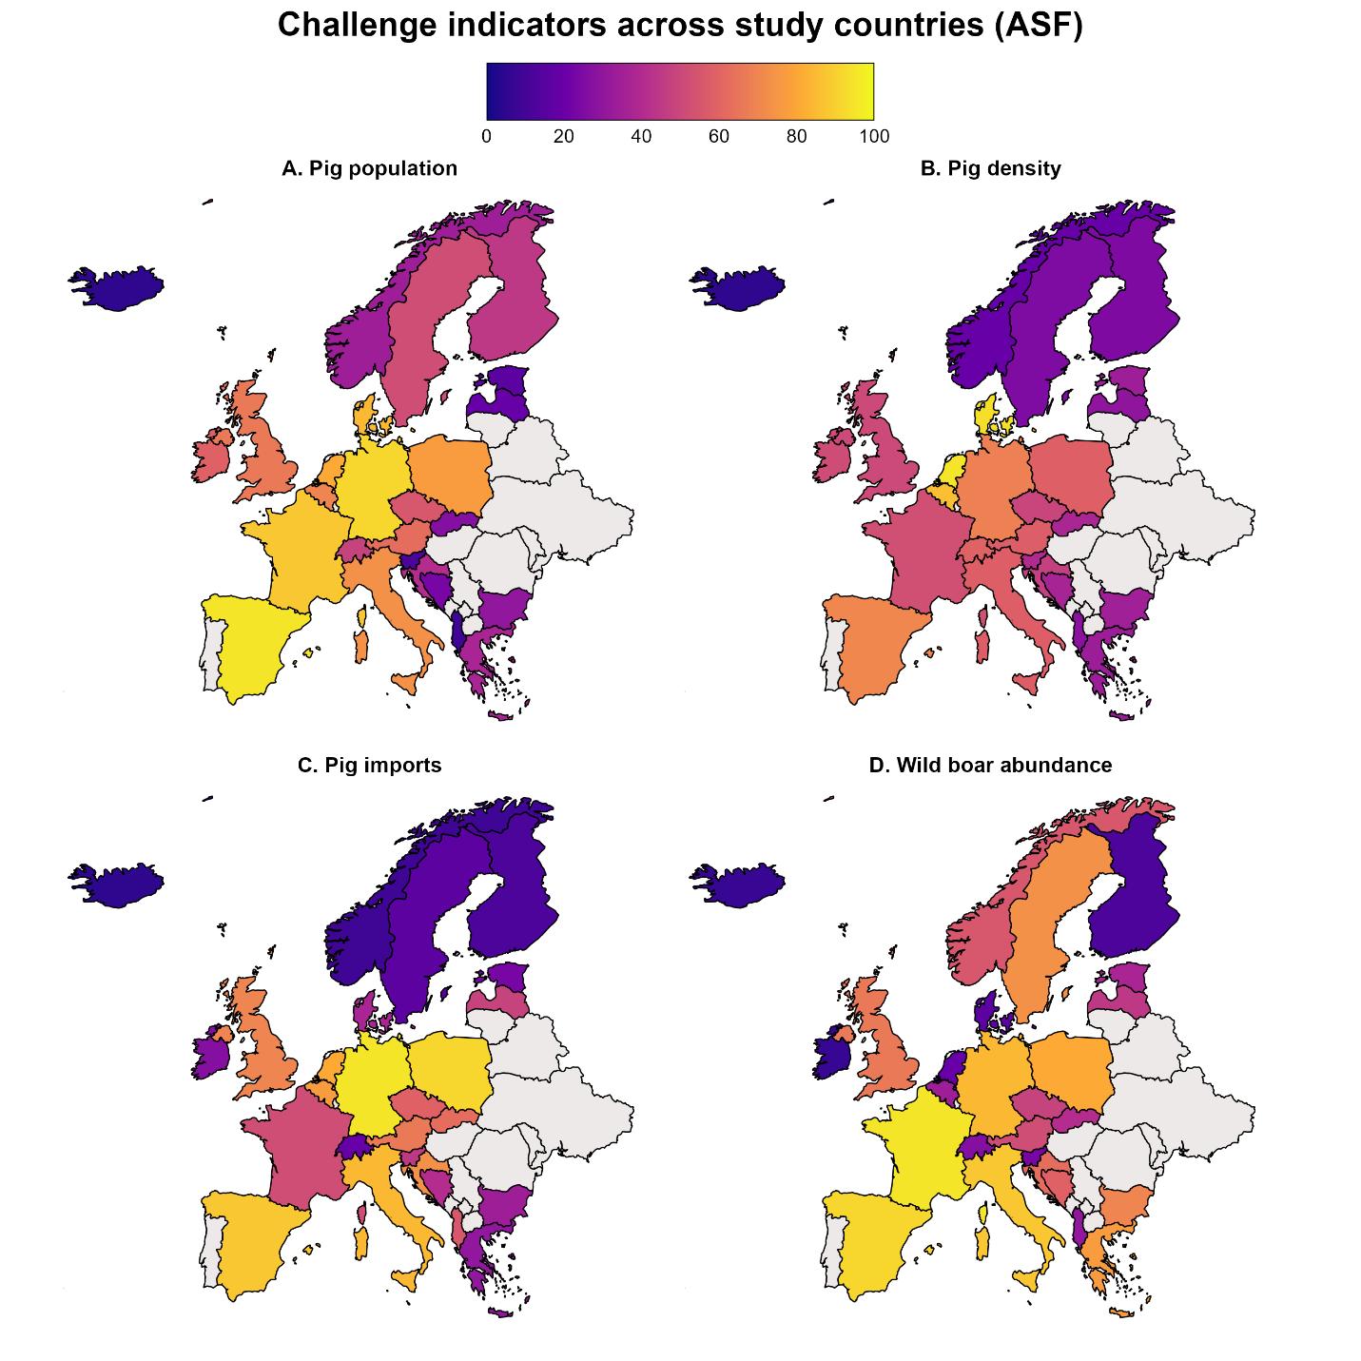
Figure S3. African swine fever (ASF) Challenge indicators: (A) pig population, (B) pig density, (C) pig imports, and (D) wild boar abundance. Panels A, C, and D show rank-scaled values, and panel B shows log-transformed, min-max scaled density. All panels share a common 0-100 color scale. The resulting Challenge Index is shown in Figure 3B. Countries shown in gray were not included in the study. Map lines delineate study areas and do not necessarily depict accepted national boundaries.
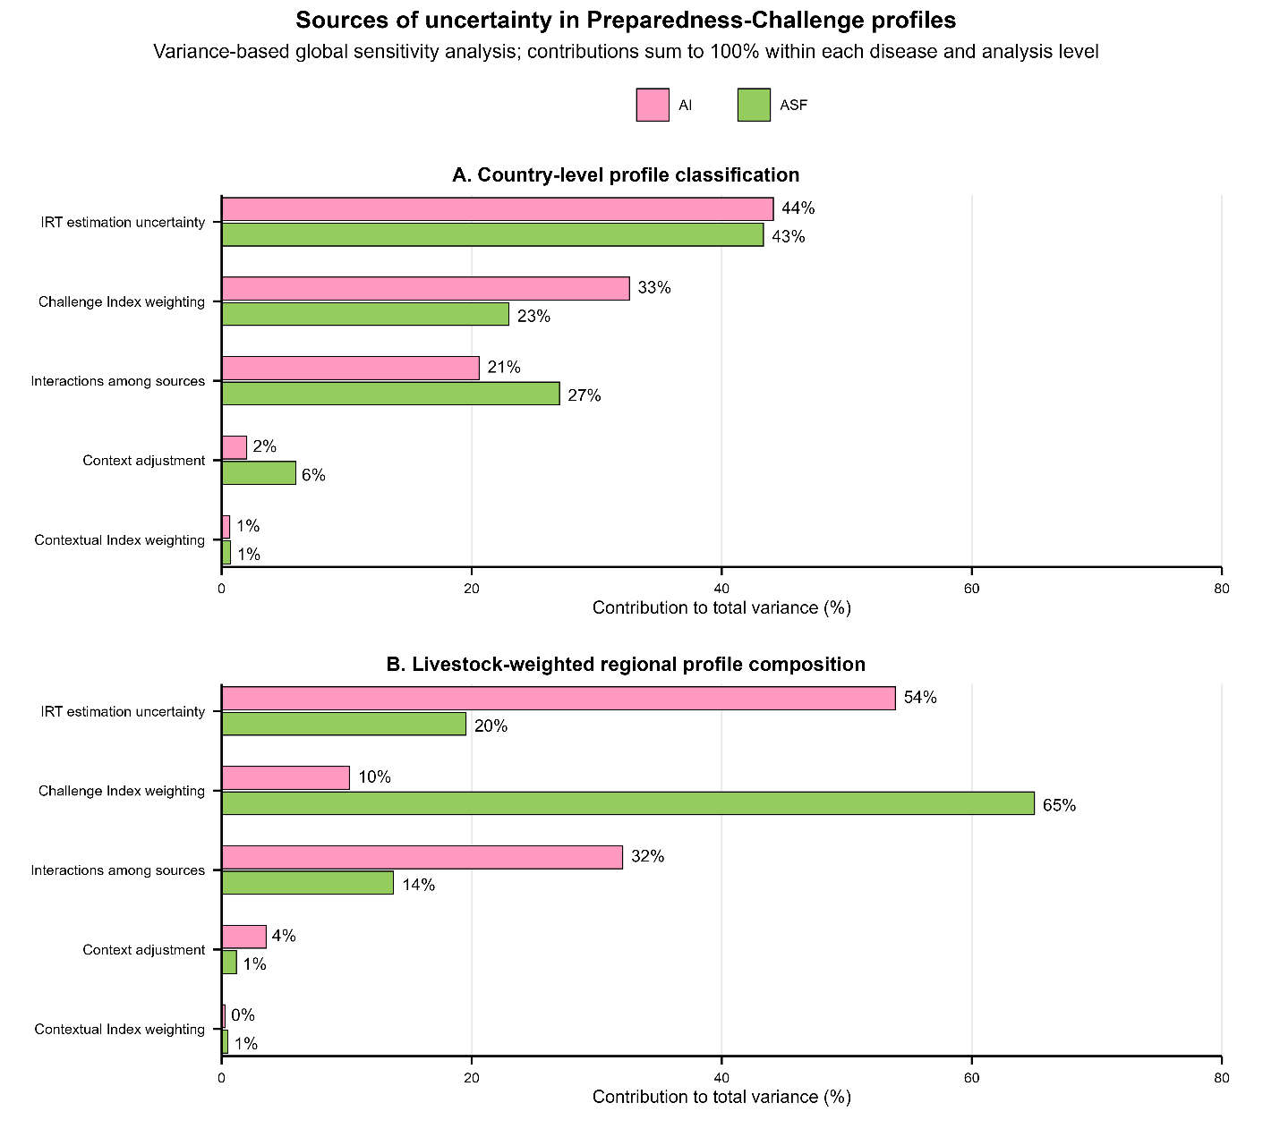
Figure S4. Sources of uncertainty in Preparedness-Challenge profiles from the variance-based global sensitivity analysis: (A) country-level profile classification and (B) livestock-weighted regional profile composition. Bars show the percentage contribution of each of four independent uncertainty sources (IRT estimation uncertainty, Contextual Index weighting, context adjustment, and Challenge Index weighting), and of their interactions, to total outcome variance for avian influenza (AI) and African swine fever (ASF). Contributions sum to 100% within each disease and panel.
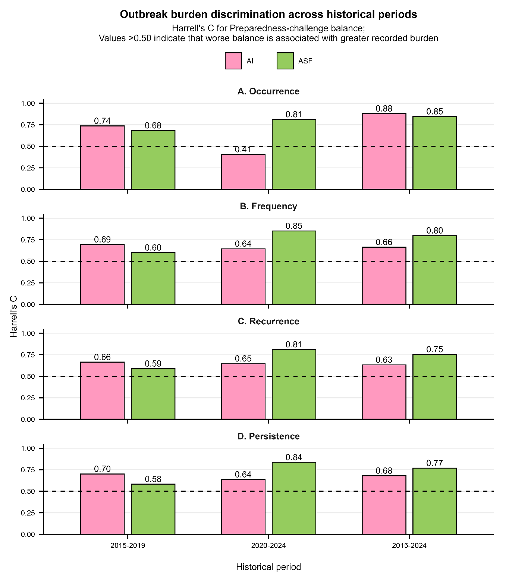
Figure S5. Concordance between Preparedness-Challenge balance and recorded African swine fever (ASF) and avian influenza (AI) outbreak histories (WAHIS; WOAH, 2026) across three historical periods. Harrell’s C-statistic is shown for (A) occurrence (any outbreak), (B) frequency (outbreaks per year), (C) recurrence (proportion of years with an active outbreak), and (D) persistence (proportion of days with an active outbreak). Values above 0.50 indicate that countries with greater recorded burden tended to have worse balance, with the dashed line marking 0.50. Values are apparent concordance estimates, without cross-validation or hold-out adjustment.

